**Day 80 DIY**

**Q1. What is reinforcement learning?**

* Reinforcement learning is a sub-branch of Machine Learning that trains a model to return an optimum solution for a problem by taking a sequence of decisions by itself.
* We model an environment after the problem statement. The model interacts with this environment and comes up with solutions all on its own, without human interference. To push it in the right direction, we simply give it a positive reward if it performs an action that brings it closer to its goal or a negative reward if it goes away from its goal.

**Q2. How does Reinforcement Learning work?**

* To understand the working process of the RL, we need to consider two main things:
* **Environment:** It can be anything such as a room, maze, football ground, etc.
* **Agent:** An intelligent agent such as AI robot.
* Let’s see some simple example which helps you to illustrate the reinforcement learning mechanism.
* Consider the scenario of teaching new tricks to your cat
* As cat doesn’t understand English or any other human language, we can’t tell her directly what to do. Instead, we follow a different strategy.
* We emulate a situation, and the cat tries to respond in many different ways. If the cat’s response is the desired way, we will give her fish.
* Now whenever the cat is exposed to the same situation, the cat executes a similar action with even more enthusiastically in expectation of getting more reward(food).
* That’s like learning that cat gets from “what to do” from positive experiences.
* At the same time, the cat also learns what not do when faced with negative experiences.

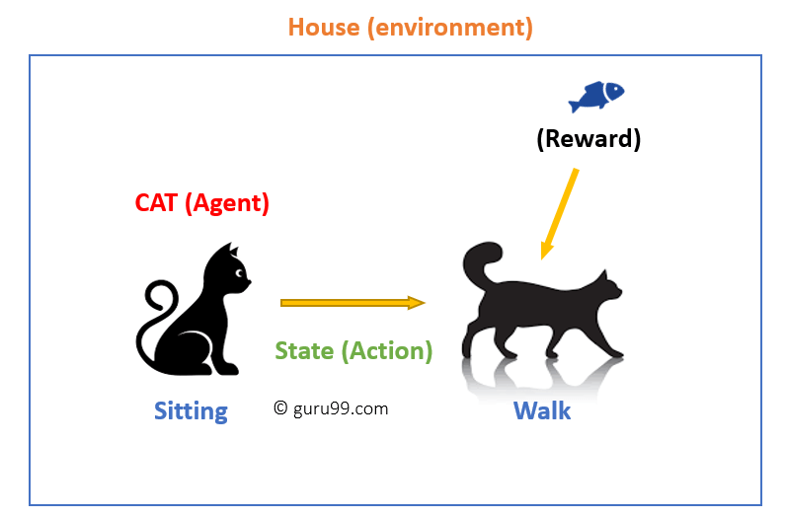

**Example of Reinforcement Learning**

**Q3. Explain a few applications of Reinforcement Learning with**

**examples.**

# **10 Real-Life Applications of Reinforcement Learning**

* In **Reinforcement Learning (RL)**, agents are trained on a **reward** and **punishment** mechanism. The **agent** is rewarded for correct moves and punished for the wrong ones. In doing so, the agent tries to minimize wrong moves and maximize the right ones.

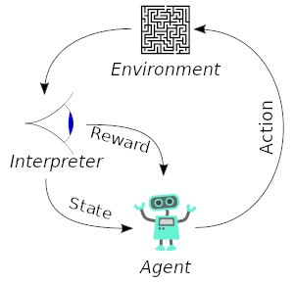[Source](https://upload.wikimedia.org/wikipedia/commons/1/1b/Reinforcement_learning_diagram.svg)

* In this article, we’ll look at some of the real-world applications of reinforcement learning.

## **Applications in self-driving cars**

* Various papers have proposed for **autonomous driving**. In self-driving cars, there are various aspects to consider, such as speed limits at various places, drivable zones, avoiding collisions — just to mention a few.
* Some of the autonomous driving tasks where reinforcement learning could be applied include trajectory optimization, motion planning, dynamic pathing, controller optimization, and scenario-based learning policies for highways.
* For example, parking can be achieved by learning automatic parking policies. Lane changing can be achieved using[Q-Learning](https://towardsdatascience.com/simple-reinforcement-learning-q-learning-fcddc4b6fe56) while overtaking can be implemented by learning an overtaking policy while avoiding collision and maintaining a steady speed thereafter.
* [AWS DeepRacer](https://aws.amazon.com/fr/deepracer/) is an autonomous racing car that has been designed to test out RL in a physical track. It uses cameras to visualize the runway and a reinforcement learning model to control the throttle and direction.

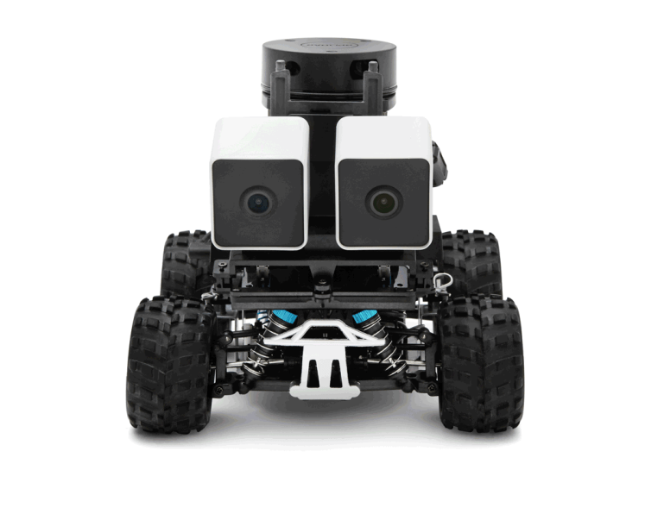

* Wayve.ai has successfully applied reinforcement learning to training a car on how to **drive in a day.** They used a deep reinforcement learning algorithm to tackle the lane following task. Their network architecture was a deep network with 4 convolutional layers and 3 fully connected layers. The example below shows the lane following task. The image in the middle represents the driver’s perspective.



## **Industry automation with Reinforcement Learning**

* In industry reinforcement, learning-based **robots** are used to perform various tasks. Apart from the fact that these robots are more efficient than human beings, they can also perform tasks that would be dangerous for people.
* A great example is the use of AI agents by[Deepmind to cool Google Data Centers](https://deepmind.com/blog/article/safety-first-ai-autonomous-data-centre-cooling-and-industrial-control). This led to a 40% reduction in **energy spending**. The centers are now fully controlled with the AI system without the need for human intervention. There is obviously still supervision from data center experts. The system works  in the following way:
* Taking snapshots of data from the data centers every five minutes and feeding this to deep neural networks
* It then predicts how different combinations will affect future energy consumptions
* Identifying actions that will lead to minimal power consumption while maintaining a set standard of safety criteria
* Sending  and implement these actions at the data center
* The actions are verified by the local control system.

## **Reinforcement Learning applications in trading and finance**

* Supervised[**time series**](https://arxiv.org/ftp/arxiv/papers/1803/1803.03916.pdf) models can be used for predicting future sales as well as predicting **stock prices**. However, these models don’t determine the action to take at a particular stock price. Enter Reinforcement Learning (RL). An RL agent can decide on such a task; whether to hold, buy, or sell. The RL model is evaluated using market benchmark standards in order to ensure that it’s performing optimally.
* This automation brings consistency into the process, unlike previous methods where analysts would have to make every single decision.[IBM](https://medium.com/inside-machine-learning/reinforcement-learning-the-business-use-case-part-2-c175740999) for example has a sophisticated reinforcement learning based platform that has the ability to make **financial trades**. It computes the reward function based on the loss or profit of every financial transaction.

## **Reinforcement Learning in NLP (Natural Language Processing)**

* In NLP, RL can be used in **text summarization**, **question answering,** and **machine translation**just to mention a few.
* The authors of this[paper](https://homes.cs.washington.edu/~eunsol/papers/acl17eunsol.pdf) Eunsol Choi, Daniel Hewlett, and Jakob Uszkoreit propose an RL based approach for question answering given long texts. Their method works by first selecting a few sentences from the document that are relevant for answering the question. A slow RNN is then employed to produce answers to the selected sentences.

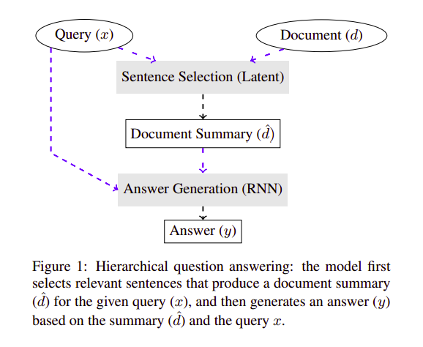

* A combination of supervised and reinforcement learning is used for[abstractive text summarization in this paper](https://arxiv.org/pdf/1705.04304.pdf). The paper is fronted by Romain Paulus, Caiming Xiong & Richard Socher. Their goal is to solve the problem faced in **summarization** while using Attentional, RNN-based encoder-decoder models in longer documents. The authors of this paper propose a neural network with a novel intra-attention that attends over the input and continuously generates output separately. Their training methods are a combo of standard supervised word prediction and reinforcement learning.

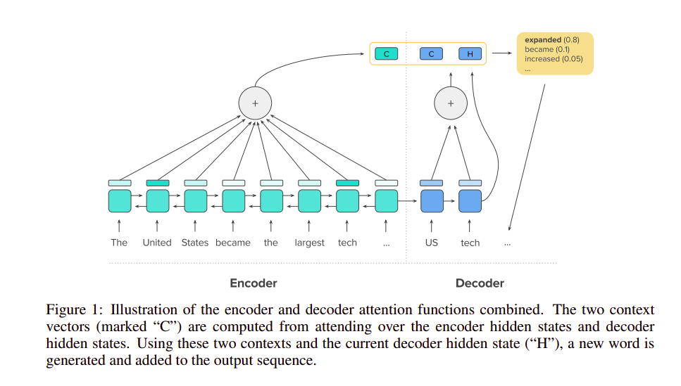

* On the side of machine translation, [authors from the University of Colorado and the University of Maryland](http://users.umiacs.umd.edu/~jbg/docs/2014_emnlp_simtrans.pdf), propose a reinforcement learning based approach to simultaneous **machine translation**. The interesting thing about this work is that it has the ability to learn when to trust the predicted words and uses RL to determine when to wait for more input.

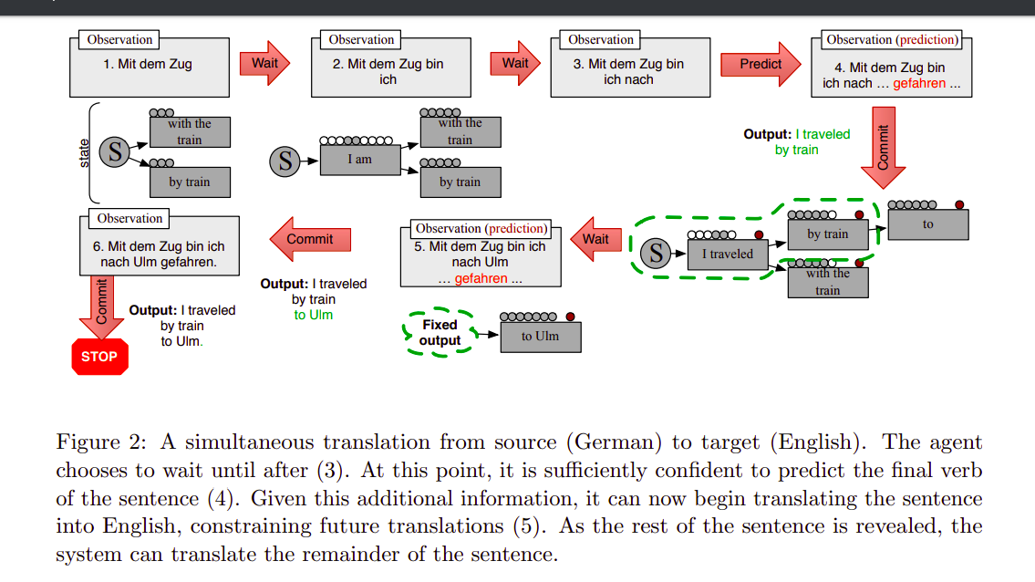

* Researchers from Stanford University, Ohio State University, and Microsoft Research have fronted Deep RL for use in[dialogue generation](https://arxiv.org/pdf/1606.01541.pdf). The deep RL can be used to model future rewards in a **chatbot dialogue.** Conversations are simulated using two virtual agents. Policy gradient methods are used to reward sequences that contain important conversation attributes such as coherence, informativity, and ease of answering.

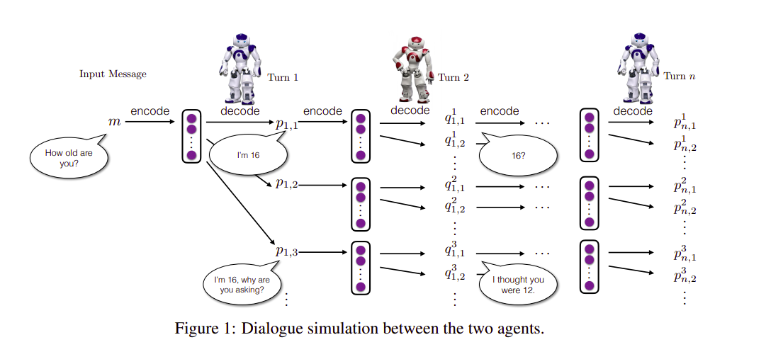

## **Reinforcement Learning applications in healthcare**

* In healthcare, patients can **receive treatment** from policies learned from RL systems. RL is able to find optimal policies using previous experiences without the need for previous information on the mathematical model of biological systems. It makes this approach more applicable than other control-based systems in healthcare.
* RL in healthcare is categorized as [dynamic treatment regimes(DTRs)](https://arxiv.org/pdf/1908.08796.pdf)in chronic disease or critical care, automated medical diagnosis, and other general domains.

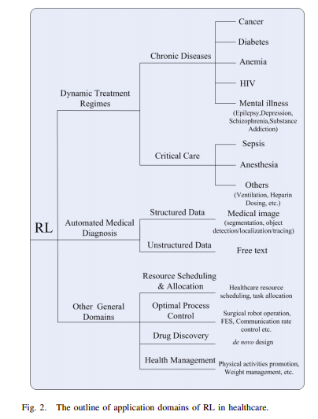

* In DTRs the input is a set of clinical observations and assessments of a patient. The outputs are the treatment options for every stage. These are similar to states in RL. Application of RL in DTRs is advantageous because it is capable of determining time-dependent decisions for the best treatment for a patient at a specific time.
* The [use of RL in healthcare](https://arxiv.org/pdf/1908.08796.pdf)also enables improvement of long-term outcomes by factoring the delayed effects of treatments.
* RL has also been used for the discovery and generation of optimal DTRs for chronic diseases.
* You can dive deeper into RL applications in healthcare by exploring this[paper](https://arxiv.org/pdf/1908.08796.pdf).

## **Reinforcement Learning applications in engineering**

* In the engineering frontier, Facebook has developed an **open-source reinforcement learning platform**— [Horizon](https://engineering.fb.com/ml-applications/horizon/). The platform uses reinforcement learning to optimize large-scale production systems. Facebook has used Horizon internally:
* to personalize suggestions
* deliver more meaningful notifications to users
* optimize video streaming quality.
* Horizon also contains workflows for:
* simulated environments
* a distributed platform for data preprocessing
* training and exporting models in production.
* A classic example of reinforcement learning in video display is serving a user a low or high bit rate video based on the state of the video buffers and estimates from other machine learning systems.
* Horizon is capable of handling production-like concerns such as:
* deploying at scale
* feature normalization
* distributed learning
* serving and handling datasets with high-dimensional data and thousands of feature types.

## **Reinforcement Learning in news recommendation**

* User preferences can change frequently, therefore[**recommending news**](http://www.personal.psu.edu/~gjz5038/paper/www2018_reinforceRec/www2018_reinforceRec.pdf) to users based on reviews and likes could become obsolete quickly. With reinforcement learning, the RL system can track the reader’s return behaviors.
* Construction of such a system would involve obtaining news features, reader features, context features, and reader news features. News features include but are not limited to the content, headline, and publisher. Reader features refer to how the reader interacts with the content e.g clicks and shares. Context features include news aspects such as timing and freshness of the news. A reward is then defined based on these user behaviors.

## **Reinforcement Learning in gaming**

* Let’s look at an application in the **gaming** frontier, specifically **AlphaGo Zero**. Using reinforcement learning, AlphaGo Zero was able to learn the game of Go from scratch. It learned by playing against itself. After 40 days of self-training, Alpha Go Zero was able to outperform the version of Alpha Go known as Master that has defeated[world number one Ke Jie](https://deepmind.com/alphago-china). It only used black and white stones from the board as input features and a single neural network. A simple tree search that relies on the single neural network is used to evaluate positions moves and sample moves without using any[Monte Carlo](https://en.wikipedia.org/wiki/Monte_Carlo_method) rollouts.

## **Real-time bidding— Reinforcement Learning applications in marketing and advertising**

* In this[paper](https://arxiv.org/pdf/1802.09756.pdf), the authors propose **real-time bidding** with multi-agent reinforcement learning. The handling of a large number of advertisers is dealt with using a clustering method and assigning each cluster a strategic bidding agent. To balance the trade-off between the competition and cooperation among advertisers, a Distributed Coordinated Multi-Agent Bidding (DCMAB) is proposed.
* In marketing, the ability to accurately target an individual is very crucial. This is because the right targets obviously lead to a high return on investment. The study in this paper was based on[Taobao](http://taobao.com/) — the largest e-commerce platform in China. The proposed method outperforms the state-of-the-art single-agent reinforcement learning approaches.

## **Reinforcement Learning in robotics manipulation**

* The use of deep learning and reinforcement learning[can train robots](https://ai.googleblog.com/2018/06/scalable-deep-reinforcement-learning.html) that have the ability to grasp various objects — even those unseen during training. This can, for example, be used in building products in an assembly line.
* This is achieved by combining large-scale distributed optimization and a variant of[deep Q-Learning](https://en.wikipedia.org/wiki/Q-learning) called[QT-Opt](https://arxiv.org/abs/1806.10293). QT-Opt support for continuous action spaces makes it suitable for robotics problems. A model is first trained offline and then deployed and fine-tuned on the real robot.
* Google AI applied this approach to**robotics grasping** where 7 real-world robots ran for 800 robot hours in a 4-month period.

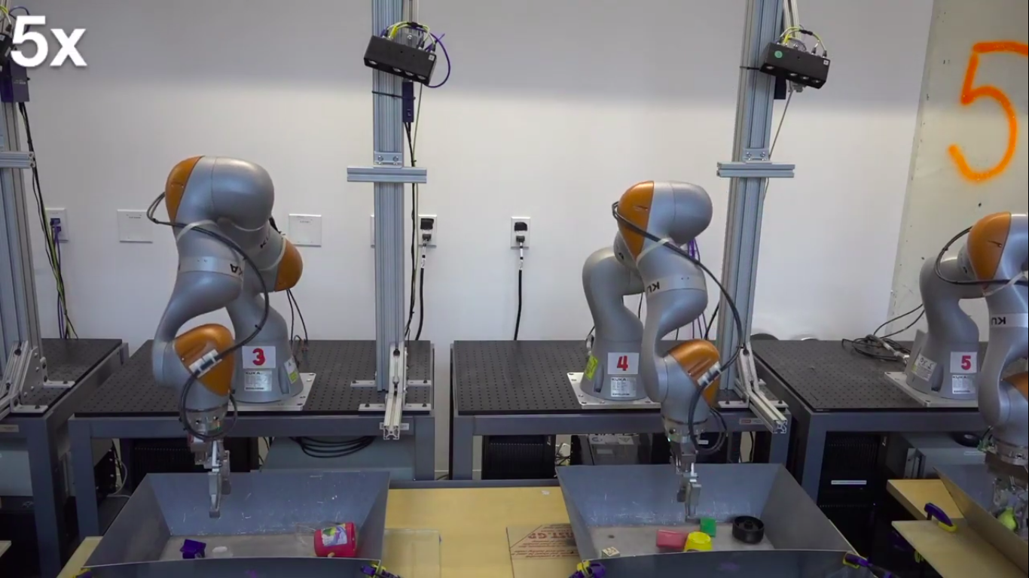

* In [this experiment](https://www.youtube.com/watch?v=W4joe3zzglU), the QT-Opt approach succeeds in 96% of the grasp attempts across 700 trials grasps on objects that were previously unseen. Google AI’s previous method had a 78% success rate.

**Q4. Explain the types of Reinforcement Learning.**

There are mainly two types of reinforcement learning:

**Positive Reinforcement:**It can be understood as an event, which occurs due to specific behaviour. Positive Reinforcement Learning gives a positive impact on the action, which is taken by the agent, and it increases the two factors of the behaviour:

* Strength
* Frequency
* Positive reinforcement can sustain the change for a long-interval. But more than limit, it may lead overloading of states that can reduce the consequences.

**Negative Reinforcement:**In terms of nature of process, it is contrary to or opposite of positive Reinforcement Learning. It can be said as the event, which aims to strengthen the behaviour that occurs due to a negative condition which have to be stopped, or avoided. It is defined to have minimum performance.

**Q5. What are the challenges of using Reinforcement Learning?**

### ****Sample efficiency****

* One of the major challenges with RL is efficiently learning with limited samples. Sample efficiency denotes an algorithm making the most of the given sample. Essentially, it is also the amount of experience the algorithm has to generate during training to reach efficient performance. The challenge is it takes the RL system a considerable amount of time to be efficient. For instance, [DeepMind’s](https://analyticsindiamag.com/a-historical-tale-of-deepminds-games/) AlphaGoZero played five million Go games before beating the world champion in it.
* [A research paper by Gen Li Princeton](https://arxiv.org/pdf/2105.08024.pdf) et al. described this as, “Given that the state space and the action space could both be unprecedentedly enormous, it is often infeasible to request a sample size exceeding the fundamental limit set forth by the ambient dimension in the tabular setting. As a result, the quest for sample efficiency cannot be achieved in general without exploiting proper low-complexity structures underlying the problem of interest.” [An IEEE paper](https://ieeexplore.ieee.org/document/9655259/figures#figures) introduced the ‘safe set algorithm’ as a solution. The algorithm monitors and modifies control and evaluates RL in a clustered dynamic environment, challenging existing RLs.

### ****Reproducibility issues****

* “When combined with the unavailability of code and models, the result is that the approach is very difficult, if not impossible, to reproduce, study, improve upon, and extend,” said [Facebook research](https://arxiv.org/pdf/1902.04522.pdf) in their quest to reproduce DeepMind’s AlphaZero (the team succeeded ultimately).
* Neural networks are opaque black boxes whose workings are mysteries to even the creators. They are also increasing in size and complexity, backed by huge datasets, computing power and hours of training. These factors make RL models very difficult to replicate.
* In recent years, there’s been a growing movement in AI to counteract the so-called [reproducibility crisis](https://www.nature.com/articles/d41586-019-03895-5), a high-stakes version of the classic it-worked-on-my-machine coding problem. The crisis manifests in problems ranging from AI research that selectively reports algorithm runs to idealised results courtesy of heavy GPU firepower.
* The [Leiden Institute of Advanced Computer Science](https://arxiv.org/pdf/2203.01075.pdf) paper suggests leveraging the ‘minimal traces’ concept. The idea supports “re-simulation of action sequences in deterministic RL environments”, allowing reviewers to verify, re-use, and manually inspect experimental results without needing large compute clusters. Other solutions include tracking and logging experiments, submitting code and creating a metadata repository.
* Second, rather than having entrants submit their agents, which could conceivably be trained with research-lab levels of GPU wattage, they’re required to submit code trained using the organisers’ machine. Finally, they also introduce randomising elements to make sure results track across different game versions.

### ****Performing in real-life scenarios****

* RL agents learn from exploration of the artificial environments. Talking about AlphaZero, [DeepMind said](https://deepmind.com/blog/article/generally-capable-agents-emerge-from-open-ended-play), “Through [reinforcement learning](https://en.wikipedia.org/wiki/Reinforcement_learning) (RL), this single system learnt by playing round after round of games through a repetitive process of trial and error.” The agents can fail in manufactured environments, but they do not have the opportunity to fail and learn in real-life scenarios. Usually, in real environments, the agent lacks the space to observe the environment well enough to use past training data to decide on a winning strategy. This also includes the reality gap, where the agent cannot gauge the difference between the learning simulation and the real world.
* General techniques used by researchers include learning by mimicking the behaviour desired, learning through accurate simulations, better algorithm design and demonstrations and, most popularly used, training the agents on a reward and punishment mechanism. Since the agent is rewarded for correct actions and punished for incorrect ones, it is trained to maximise the right ones.

### ****Sparse rewards****

* The reward technique discussed in the previous point is not foolproof. Since the rewards are sparsely distributed in the environment, a possible issue is an agent not observing the situation enough to notice the reward signals and maximise specific actions. This also occurs when the environment cannot provide reward signals in time; for instance, in many situations, the agent receives a green flag only when it is close enough to the target.
* Curiosity-driven methods are widely used to encourage the agent to explore the environment and learn to tackle tasks in it. The researchers in the paper ‘Curiosity-driven exploration by self-supervised prediction’ proposed an Intrinsic Curiosity Module (ICM) to support the agent in exploration and prompt it to choose actions based on reduced errors. Another approach is curriculum learning, where the agent is presented with various tasks in ascending order of complexity. This imitates the learning order of humans.

### ****Offline reinforcement****

* While in real RL, the agent incrementally improves its policy with new experiences, [offline RL](https://analyticsindiamag.com/how-to-address-offline-reinforcement-learning-challenges/) works on a fixed set of logged experiences with minimal interaction with the environment. This method eliminates the need for repeated training of AI agents to scale. Still, it proposes the challenge where if the model, which is being trained with an existing dataset, takes action different from the data collection agent, one cannot determine the reward provided to the learning model.
* Another issue, as suggested by [Google AI](https://ai.googleblog.com/2020/08/tackling-open-challenges-in-offline.html), is the distributional shift. This occurs when the RL algorithms must learn to make decisions that differ from the decisions taken in the dataset to improve over the historical data.
* The team developed a solution for this, an offline RL algorithm ‘[conservative Q-learning](https://sites.google.com/view/cql-offline-rl) (CQL)’, that guards “against overestimation while avoiding explicit construction of a separate behaviour model and without using importance weights.” Researchers have also found that online RL agents work well in the offline setting with sufficiently diverse datasets.